[E134] High voltage PCB

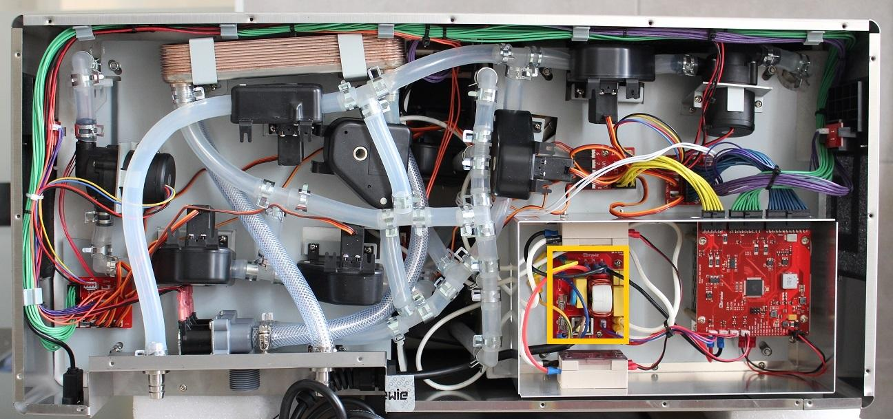

Unscrew the marked fastening screws and unplug all the cables connected to the PCB.

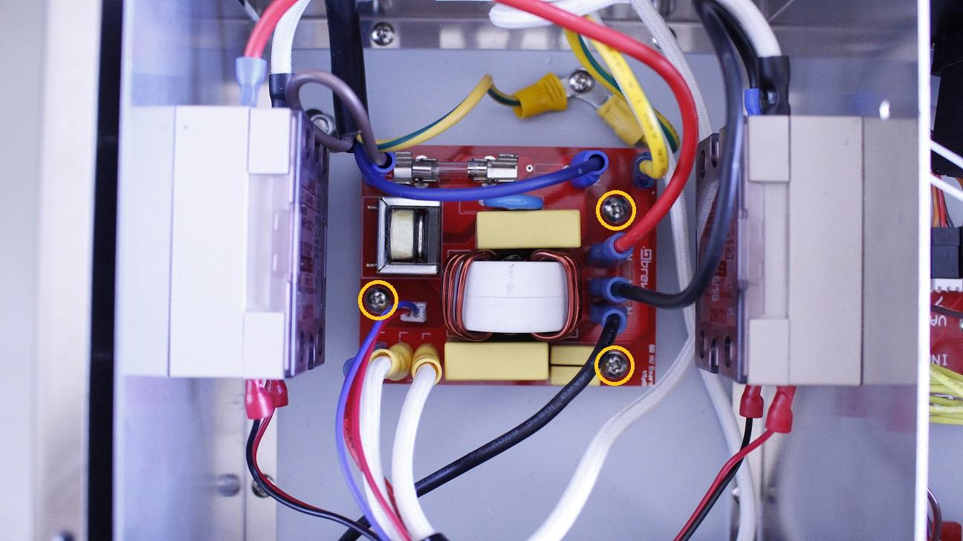

Now the PCB can be removed.

Reassemble consists of the same steps in reverse.